**Introduction to the feasibility analysis of the GoSafe :-**

The preliminary objective of the feasibility analysis was to test the Technical, Operational, Economical feasibility in order to support the starting phase of GoSafe. Ideally, all the systems are feasible if they are equipped with Unlimited time and infinite resources. We are going to be the new people new in this area and needed to compete with much evolved organizations so we focused on following aspects :-

1. **Technical Feasibility :-**

The website is totally web based so only hardware that we require on our side is a Computer and a server which will help to practically implement our project in the current scenario. The current system will be able to upgrade for better performance after the establishment of the system and server.

1. **Operation Feasibility :-**

The organizational feasibility is the aspect of the feasibility which is important part in implementation of the project. Some of the important aspects include sufficient support for user management, the smooth working of the system for large traffic on website. The new technology needed for this website are low cost but with the increase in data traffic

1. **Economical Feasibility :-**

This is one of the main aspects which will let us take a visionary preview of the system to be implemented. In the Economical Feasibility, the development cost in creating the system and implementing the system are mainly involved. The Financial benefits must be at least equal to the cost at first then it should gradually increase so that after cost cutting the website should earn a good amount of profit to evolve overtime.

1. **Behavioral Feasibility :-**

The website requires no user guidance or manual as it is easy to use and understand and also has a user friendly interface. The application works in accordance with the design.

1. **People’s opinion, their suggestion and their commitment to use the website. :-**

To become more sure about what people will think about our website we have conducted an online survey of people through google form which helped us allot to get suggestions and explore more in the development part of ours. We gave some basic questions about the website feature and to know the thinking of customers and had a good response for all of them as well as our sharing feature. People were mostly delighted to hear about sharing feature actually about 98% people like the sharing feature so much that in future it is going to be the trademark for our success. We also got so many suggestions about improving our website, some of them were to develop an android app, they related us with ola and uber too and were happy for our initiative. Some more suggestions were telling us that it should give special preferences to the university people and also can access it from the moodle system somehow so that after the gatepass is approved they can book a cab rightaway.

Here I have added some pie charts of responses that we got from people:-

1. Responses for question 1 :-

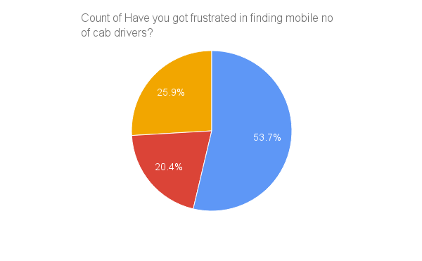

1. Responses for question 2 :-

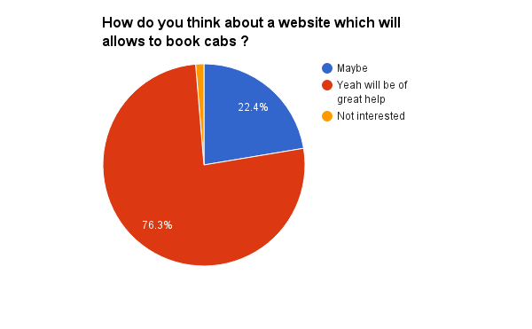

1. Responses for question 3 :-

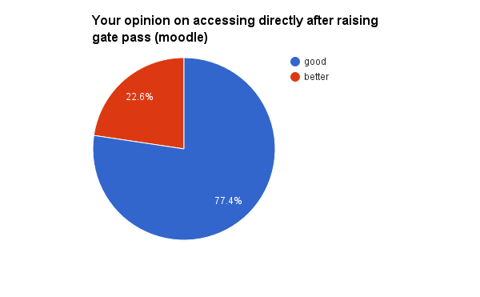

1. Responses for question 4 :-

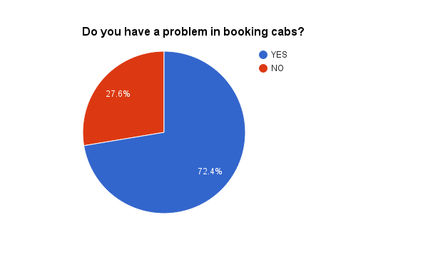

1. Responses for question 5 :-

